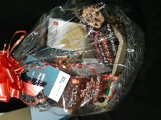
- PC Baking Gift Basket
(2 chances to win)
Donated by Superstore, Milton

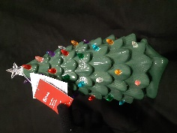
- Christmas Tree Decoration
Donated by Canadian Tire,
Georgetown

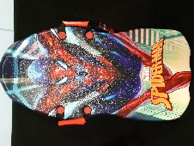
- Spiderman Snow Sled
Donated by Canadian Tire,
Georgetown

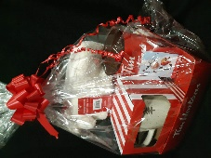
- Tim Hortons Gift Pack
Donated by Tim Hortons, Acton

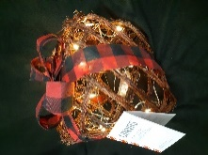
- Light-up Present Decoration
Donated by Canadian Tire,
Georgetown

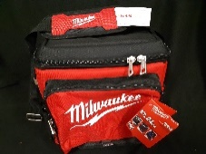
- Milwaukee Packout Cooler
Donated by Noble, Milton

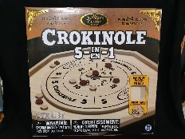
- Crokinole Game Superstore Milton Donated by Canadian Tire,
Georgetown
fdfdc
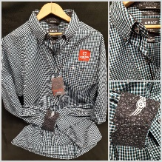
- Ariat Dress Shirt
Size: Men’s Large
Donated by Bill Chapman
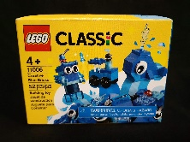
- Lego Classic Blue Bricks Set
Donated by Canadian Tire,
Georgetown
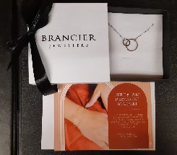
- Silver Necklace &
Voucher for Little Links
permanent bracelet
length: approximately 40cm
Donated by Brancier, Milton
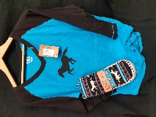
- Lazy One Shirt & Slipper Set
(2 chances to win)
Size: shirt adult Large,
slippers Large/Extra-large
Donated by Julie Hellam

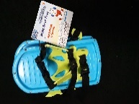
- Snow Bear Feet
Donated by Canadian Tire,
Georgetown
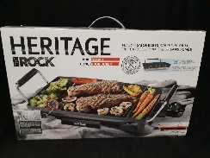
- Indoor Barbeque Grill
Donated by Canadian Tire,
Georgetown
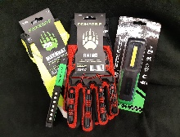
- Work Glove Pack
Donated by Lumberville, Milton
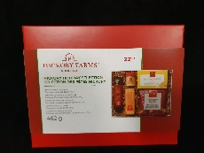
- Hickory Farms Holiday
Selection
Donated by Canadian Tire,
Georgetown
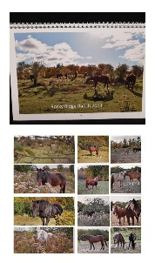
- RRR 2023 Horse Calendar
Donated by Emily Kearns
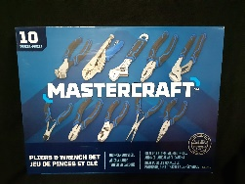
- Mastercraft Pliers &
Wrench Set
Donated by Canadian Tire,
Georgetown
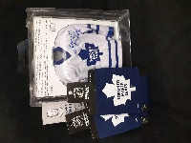
- Maple Leaf Prize pack
Includes Bower #1 mini jersey
Donated by The Sudeyko Bower Family
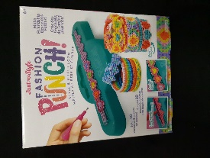
- Fashion Punch
Style & Stitch Loom
Donated by Canadian Tire,
Georgetown
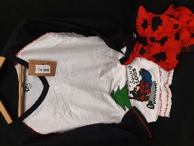
- Lazy One Pajama Set
(2 chances to win)
Size: Adult Extra Large
Donated by Julie Hellam
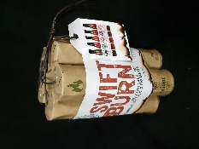
- Swift Burn Hot Sauce Set
Donated by Canadian Tire,
Georgetown
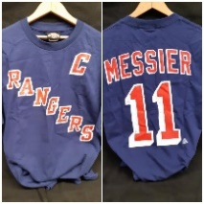
- NY Rangers Messier T-shirt
Size: Adult Large
Donated by The Sudeyko Bower
Family
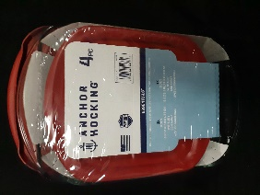
- Anchor Hocking 4 piece
Bake Set
Donated by Canadian Tire,
Georgetown
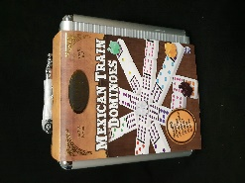
- Mexican Train Dominos
Donated by Canadian Tire,
Georgetown
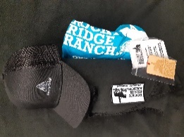
- RRR Prize Pack
Includes pony ride gift certificate
Donated by Rocky Ridge Ranch

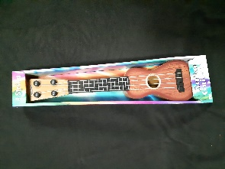
- Toy Ukulele
Donated by Canadian Tire,
Georgetown
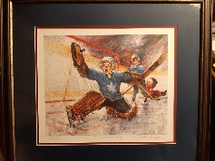
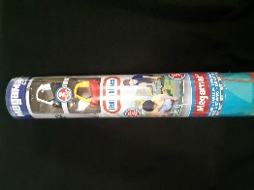
- Little Tikes MegaMat
Size: 155cm x 120cm
Donated by Canadian Tire,
Georgetown
- Vintage “Goalie Save”
Print from Johnny
Bower’s art collection
Donated by The Sudeyko Bower
Family
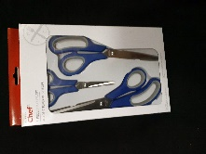
- Master Chef Scissors Set
Donated by Canadian Tire,
Georgetown
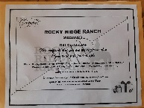
- RRR Horseback Trail Ride
Gift Certificate
1 hour trail ride for 4 people

