Choice of weeks on a first come, first serve basis
DATES

July 6 - July 10
July 13 - July 17
July 20 - July 24
July 27 - July. 31
Aug. 3 - Aug. 7
Aug. 10 - Aug. 14
Aug. 17 - Aug. 21
Aug. 24 – Aug.28

L

*** All weeks …
8 – 14 years old

Ranch Day Camps
Register &
Pay On-line

REGISTRATION FEES (HST inclusive)
(E-transfer - info@rockyridgeranch.org, Cash, Visa, Mastercard)

- Ranch Day Camp week runs Monday to Friday 8:30 a.m. to 5:00 p.m.

Regular Day Camps - $400.00 (BRING your own lunch -
PLEASE NOTE - We will hold a BBQ lunch on Fridays following strict Covid-19 guidelines)

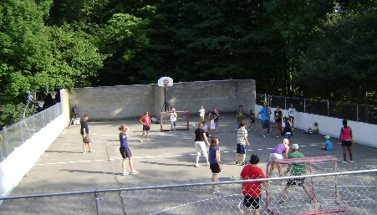

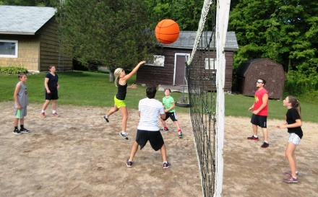
DEPOSIT FEE (Canadian Funds)

* $100.00 per ALL Day Camper Weeks with Registration Form
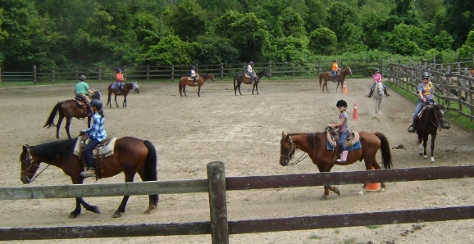
* Balance due before camp arrival
We will be following strict Covid-19 Guidelines as set out by the government and health authorities. We will be taking no-contact temperature readings as campers arrive. Campers are asked to bring face masks for use at times when social distancing may present a challenge. Parents will be asked to remain in their vehicles and the staff member assigned to the camper group will escort him/her to or from the vehicle. Each camper will be asked to agree to a code of conduct while at camp, including physical distancing, frequent handwashing and proper etiquette when coughing/sneezing. A full guideline will be available on request.
Privacy Policy: Guests can be assured that the information they provide for reservation and registration will be kept private and used solely for the purpose of their stay at Rocky Ridge Ranch.
(For complete policy please visit our website.)

RETURN ADDRESS – ROCKY RIDGE RANCH 10486 5TH LINE NASSAGAWEYA
R.R.#2 ROCKWOOD ON N0B 2K0
PHONE (905)854-2584 FAX/PHONE (905)854-0964
E-MAIL info@rockyridgeranch.org WEBSITE www.rockyridgeranch.org

