

***Choice of weeks on a first come, first serve basis - “We recommend a two week holiday”***

**DATES**

**June 28 – July 4 (13 – 17 yr olds) - A favourite for Teens!!**

**July 5 - July 11 (11-13 yr olds)**

**July 12 - July 18 (11-13 yr olds)**

**July 19 - July 25 (8 - 17)**

**July 26 - Aug. 1 (8 - 17) also Junior Day Camp - 5 – 7 year olds (July 27 – July 31)**

**Aug. 2 - Aug. 8 (8 - 17)**

**Aug. 9 - Aug. 14 *Hockey Camp (8 - 16) (Sunday - Friday)***

**Aug. 16 - Aug. 22 (8 - 17) also Junior Day Camp - 5 – 7 year olds (August 17 - 21)**

***DAY Camp is available each week***

**L**

*Ranch Camps (Residential & Day)*

Register &

Pay On-line

**REGISTRATION FEES** (HST inclusive)

(E-transfer - info@rockyridgeranch.org, Cash, Cheque, Visa, Mastercard)

* *Ranch Camp* ***week*** runs Sunday 2 p.m. to the following Saturday afternoon after the rodeo

***A Regular - 1 Child in 1 Family*** - **$645.00**  **\* Register before March 1, 2020 - one (1) free $20 tuck card!**

***B Family Rate -*** More than 1 child in same Family - $**625.00 * Register before March 1, 2020 - one (1) free $20 tuck card/child!**

**NB - *Register for a two week holiday and receive 10% off regular camp price for the second week!!***

**Hey Kids! Fill a cabin**

**with 5 or more of your**

**family and friends (must**

**be new campers) and**

**YOUR week is FREE!**

* *Day Camps* run Mon. – Fri. 8:30 – 5:00

**Regular Day & Junior Day (5 – 7 year olds) Camps - $450.00 *(includes lunch)***

**DEPOSIT FEE** **(Canadian Funds)**

**\* $200.00** per Ranch Camper Week with Registration Form

* **$100.00** per *ALL* Day Camper Weeks with Registration Form

* **$250.00** Hockey Camp with Registration Form

* Balance due on (or before) camp arrival

**\* *Deposit* non-refundable after May 15, 2020**

**\* *Cancellation fee* prior to May 15 is $50.00**

**WEEKEND RESIDENT FEE**

**$60.00** (if staying over the weekend for a second week of camp, includes laundry charges)

**NSF cheques - $30.00 charge**

*(OVER)*

**

*Hockey Camp*

***Girls & Guys * House League \****

***Select * Rep Players 8 - 16***

***August 9 – 14, 2020***

* *Hockey Camp* **runs Sunday 2 p.m. to the following Friday evening BBQ -**

*A* **Residential - $875.00**

*B*  **Day Camp *- 8:00 - 5:30*** *-* **$600.00 } Monday to Friday**

***C* Ice Time Only - 9:30 – 12:00 - $345.00 } Monday to Friday**

Powerskating with

Cindy Bower Sudeyko

**FEE INCLUDES**

• **Ice Time ● Hockey Jersey**

• **Accommodation**

• **All Meals (served family style)**

• **Horseback Riding ● Swimming**

• **All Activities**

**· Certificate · BBQ**

• **Bus to and from Arena**

• **Lots of Fun!**

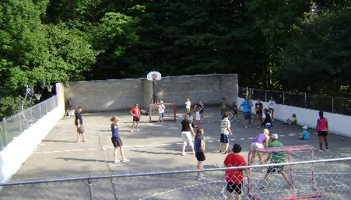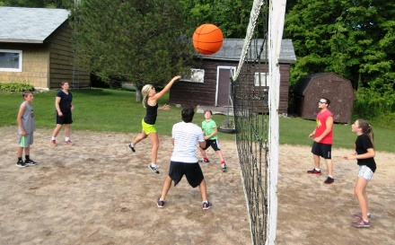

***On Ice:***

**· 2 ½ Hours per day**

• **Instructors – Retired Pros, Junior & University**

**players · Ratio 1 : 3**

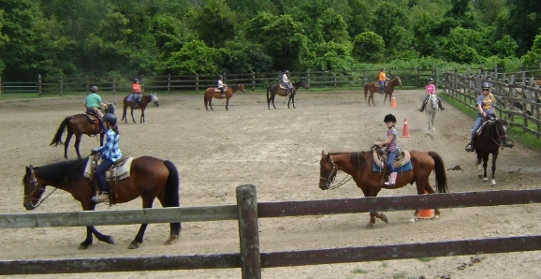• **Power Skating ● Teamwork**

• **Conditioning**

• **Skills**

**· Passing · Shooting**

**· Stickhandling**

**· Forwards/Defense**

• **Creativity (smart hockey)**



RETURN ADDRESS – ROCKY RIDGE RANCH 10486 5TH LINE NASSAGAWEYA

R.R.#2 ROCKWOOD ON N0B 2K0

PHONE (905)854-2584 FAX/PHONE (905)854-0964

E-MAIL [info@rockyridgeranch.org](mailto:info@rockyridgeranch.org) WEBSITE www.rockyridgeranch.org

Privacy Policy: Guests can be assured that the information they provide for reservation and registration will be kept private and used solely for the purpose of their stay at Rocky Ridge Ranch.

(For complete policy please visit our website.)

Privacy Policy: Guests can be assured that the information they provide for reservation and registration will be kept private and used solely for the purpose of their stay at Rocky Ridge Ranch.

(For complete policy please visit our website.)

RETURN ADDRESS – ROCKY RIDGE RANCH 10486-5TH LINE R.R.#2

ROCKWOOD ON N0B 2K0

PHONE (905)854-2584 FAX/PHONE (905)854-0964

E-MAIL [info@rockyridgeranch.org](mailto:info@rockyridgeranch.org) WEBSITE www.rockyridgeranch.org